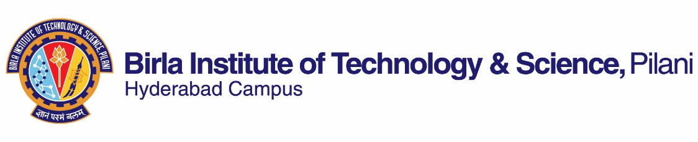

**second SEMESTER 2018-2019**

**Course Handout (Part ‑ II)**

**Date: 07.01.2019**

In addition to part‑I (General Handout for all courses appended to the time table) this portion gives further specific details regarding the course.

**Course No. : CHEM F241**

**Course Title : Inorganic Chemistry-II**

**Instructor-in-charge : Dr. Sounak Roy**

1. **Scope and Objective of the Course:** Theories of coordination chemistry, electronic spectroscopy and magnetism of complexes, organometallic chemistry and chemistry of lanthanides and actinides.
2. **Text Book:** T1. “ Inorganic Chemistry” Huheey J. E., Keiter, Ellen A., Keiter, Richard L., Medhi, O.K.; 4th ed., Pearson.

**Reference Books:** R1. "Concise Inorganic Chemistry",  Lee, J.D. 5th Edition,Wiley, India Edition.  
R2 "Inorganic Chemistry", Shriver, D.F.;  Atkins, P.W.; Overton T. L., Rourke, J. P., Weller, M. T., Armstrong, F. A.  4th edition, Oxford.  
R3  "Concepts & Models of Inorganic Chemistry" B. Douglas, D. McDaniel and J. Alexander 3rd Edn , wiley India.

1. **Course Plan:**

|  |  |  |  |
| --- | --- | --- | --- |
| **Lecture No** | **Learning Objectives** | **Topics to be covered** | **Chapter in the Text Book** |
| 1 | Coordination chemistry | Bonding  VB theory applied to coordination compounds | **T1**: 12.1-12.7 |
| 2-4 | Crystal Field Theory (CFT) | Crystal field splitting; d orbitals in different crystal fields; applications of CFT | T1:Chapter 14: 428-444 |
| 5-7 | Molecular orbital theory | Molecular orbital theory | T1:Chapter 14: 444-459 |
| 8-12 | Electronic spectra of complexes, Magnetic properties of complexes | Electronic spectra of complexes, Magnetic properties of complexes | T1:Chapter 15: 461-492 |
| 13-15 | Structure Nomenclature | Structure – Nomenclature, Coordination numbers 1, 2, 3, 4, 5, 6, 7. Generalization about coordination numbers  Isomerism: Linkage and other types of isomerism  Chelate effect | T1:Chapter 15: 461-492 |
| 16-20 | Reactions of coordinated complexes | Reactions – Nucleophilic substitution reactions, Kinetics, Mechanisms | T1:Chapter 17 (542-569) and Lecture notes |
| 21-32 | Organometallic chemistry | The 18-electron rule  Metal-carbonyl complexes  Nitrosyl complexes  Dinitrogens  Alkyls  Carbenes, Carbynes, Carbides  Alkenes  Alkynes  Metallocenes | T1:Chapter 18 and Lecture notes |
| 33-38 | Reactions of organometallic complexes | Catalysis by organometallic compounds  Stereo chemically non-rigid molecules | T1:Chapter 18 and Lecture notes |
| 39-42 | Descriptive chemistry of metals - The Lanthanides and Actinides | Descriptive chemistry of metals - The Lanthanides and Actinides. | T1:Chapter 13 (407- 419)  Lecture notes |

**4. Evaluation Scheme:**

|  |  |  |  |  |
| --- | --- | --- | --- | --- |
| **Component** | **Duration** | **Weighting (%)** | **Date and Time** | **Nature of Component** |
| Assignment | - | 20 | Continuous | Open Book |
| Mid Semester Test | 90 min | 35 | 11/3  11.00 -12.30 PM | Closed Book |
| Comprehensive  Examination**\*** | 180 min | 45 | 01/05 AN | Closed Book |

1. **Chamber Consultation Hours**: To be announced in the class.
2. **Notices**: Notices, if any, concerning the course will be displayed on the Chemistry Department Notice Board as well as in CMS.
3. **Academic Honesty and Integrity Policy**: Academic honesty and integrity are to be maintained by all the students throughout the semester and no type of academic dishonesty is acceptable.
4. **Make-up-policy:** May be granted only for genuine cases.

**Instructor-in-charge**

**Sounak Roy**

